Richard Rennehan
DBAS2104

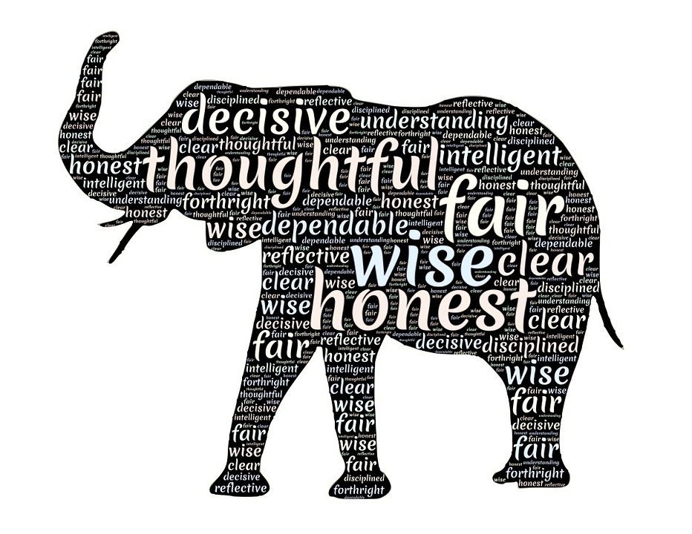
My Business Portfolio: Personality Traits and Skills
Contents

The Five Big Personality Traits 2
My Ideal Traits for a Manager 3
My “Psychological Contract” 4
Conclusion 5

The Five Big Personality Traits

In the competitive business world today, there are 5 personality traits that help you stand out. They can solely determine if you get the job and if you will stay there. The 5 personality traits are openness, conscientious, extraversion, agreeableness, and neuroticism. Respectively, they stand for how open you are to new ideas, how well you can utilize self-discipline and control, how much you enjoy social activities, how well you can cooperate and put others ahead of yourself, and how prone you are to negative emotions.

Personally, I am very open. I am always willing to hear new ideas from others and think of our world in unconventional ways. I also have a high interest in the arts, a trait of open and mindful people. I love how the arts allow people to express themselves and their ideas in novel ways. As a result, I have a great sense for adventure and creativity.

I am mostly strong when it comes to conscientiousness. There are activities I always try to get done, but there is the occasional activity I tend to hold off. Thankfully, the activities I hold off are mostly household chores while the activities I always get done on time are critical to my future success. As a student, I usually have lots of assignments, quizzes, and projects to complete at once. I strive to make sure I know how much time I’ll need to complete each assignment, then set aside the time to get them done. When I know something needs to get done, I refuse to let myself get sidetracked. I am serious about graduating with high marks and getting my face out in the expansive world of business.

With extraversion, I lie right in the middle of the scale. I am actually in the process of developing this skill. Before, I was always quiet and relatively unengaged in social situations, like group projects. I am currently working on gathering the courage to speak my mind and share my ideas with others. I aspire to get more involved in the community. My dream is to become a community leader.

I rank highly in agreeableness. That means I often demonstrate kindness, sensitivity, cooperation, and compassion towards others. I prefer to cooperate rather than compete. Agreeableness is an important trait to have because it allows a person to develop better relationships with others. In the business world, I want to make sure I’ll develop good relationships with my boss and co-workers. A sense of belonging leads to a boost in productivity.

Finally, I am moderate when it comes to neuroticism. I experience sadness, worry, anger, and guilt as much as the average person. It’s rare for me to overreact, but it has happened before. In general, I believe I experience a good mix between positive and negative emotions. I try not to let negative emotions get the best of me. Instead, I often find ways to turn negative emotions into positive emotions, leading to a boost in productivity and confidence.

My Ideal Traits for a Manager/Leader

When I picture a good manager or leader, I imagine the manager excelling at demonstrating understanding towards employees and conscientiousness towards the business’s goals

First, understanding, in my opinion, is a great trait for an executive to have. A manager or leader should be an excellent role model by demonstrating kindness, sensitivity, cooperation, and compassion towards others who do well. However, it’s just as important to know how to push the best out of each employee, especially if they are not performing up to standard. One method may work better than another for each worker, and the manager should acknowledge that. If every manager and leader looked at their employees from the inside rather than the outside, I believe our world would be tremendously more productive.

Second, an executive must be conscientious. A manager or leader must not be lazy and unproductive just because of ranking above the others. An executive should get involved with all of the workers and make sure they are helping the business move towards its goals. Being a higher-up is not an easy task.

My “Psychological Contract”

A psychological contract is an imaginary contract between an employee and employer. It lists what the employee will contribute to the company and what the employer will give back in return. The psychological contract is special because it goes beyond the oversimplified work and pay model. Here’s my psychological contract:

Me | Employer
- Loyalty  - Respect  - Honesty  - Commitment  - Effort  - Ambition  - Trust  - Hours  - Ideas  - Innovation  - Skills | - Security and Safety  - Well-Being  - Respect  - Honesty  - Personal Growth  - Employee Benefits  - Flexibility  - Empowerment and Praise  - Recognition  - Trust  - Status  - Promotions
(Notice how some traits are shared?)

To motivate me to work, I would at least need a livable wage, well-being, trust, and respect from the employer. I at least need to feel in good health while working for a business. To truly motivate me, I need to feel welcomed and understood for who I am. Employers can do that by empowering me to do my best, rewarding me with praise for good work, recognizing the effort I put into the company, understanding any special circumstances, and allowing me to learn from my mistakes.

If a pay raise was not an option after proving my worth to the company, I would gladly accept more attention and praise instead.

Conclusion

It will only be two years from now until I graduate from NSCC. I remember thinking as a child that two years was a long time. Now, two years seems to zip right by!

When I graduate, I know I will be ready for the business world. I believe I am the exact person the troubled technology industry needs right now. I have a good mix of the 5 big personality traits, and I have a good idea of what the business world will be like. My passion for the technology field will allow me to leap over the competition. Get ready world, because here I come!

